Secure Acceptance Hosted Checkout – Simple Documentation

- Configure the credentials in the config.php file as shown below
Ie. Merchant id, Profile_id, Access_Key, Secret_Key and Cybs_Base_URL

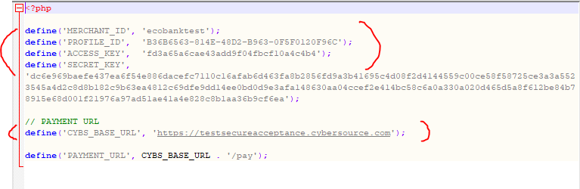

- Launch the payment form payment_form.php and click Default All button to populate the textboxes and then click on Submit.
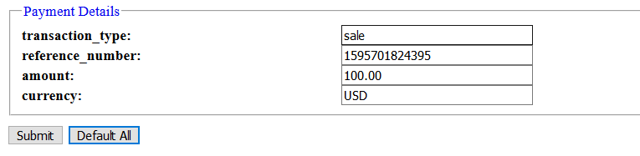

- On the payment confirmation page, click Confirm.

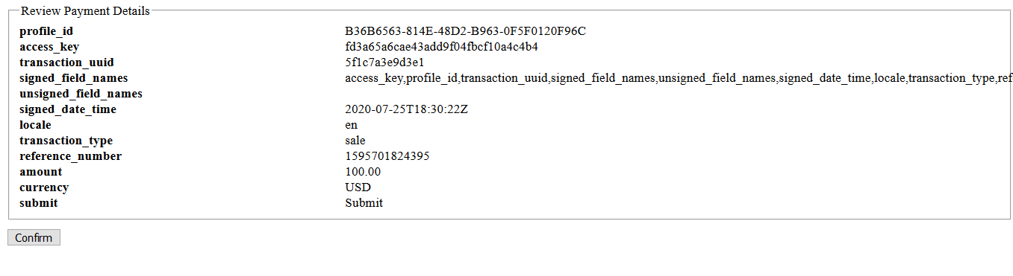
- On the payment page, input the billing information and card details and then click on Pay.
Sample card details
Card | Number | CVV/ CVN
VISA | 4000 0000 0000 0002 | 123
VISA | 4242 4242 4242 4242 | 123
MasterCard | 5555 5555 5555 4444 | 123

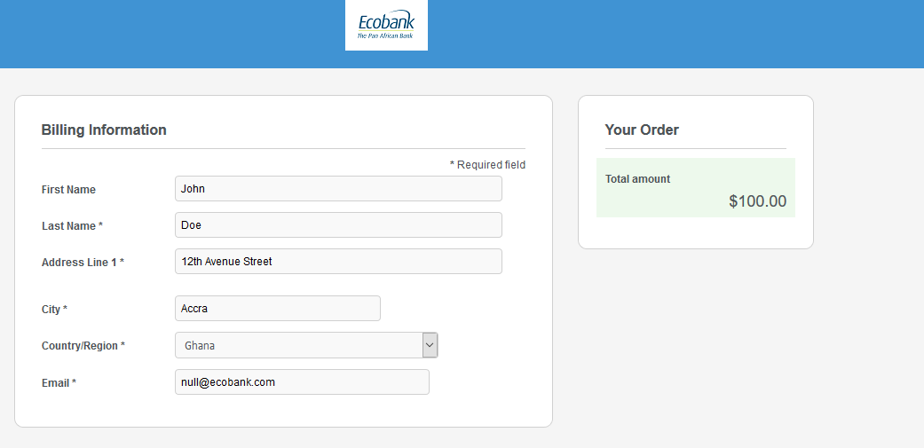

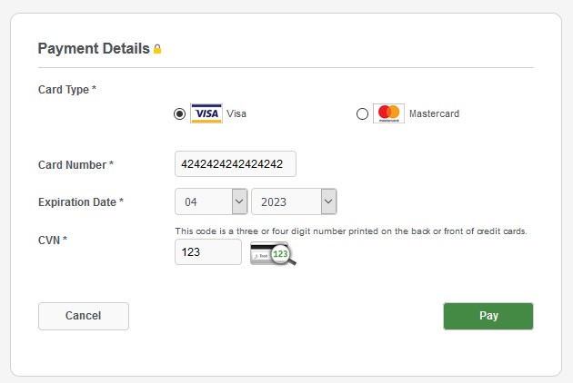

- Enter the 3D secure password (eg. 1234) and click Submit.
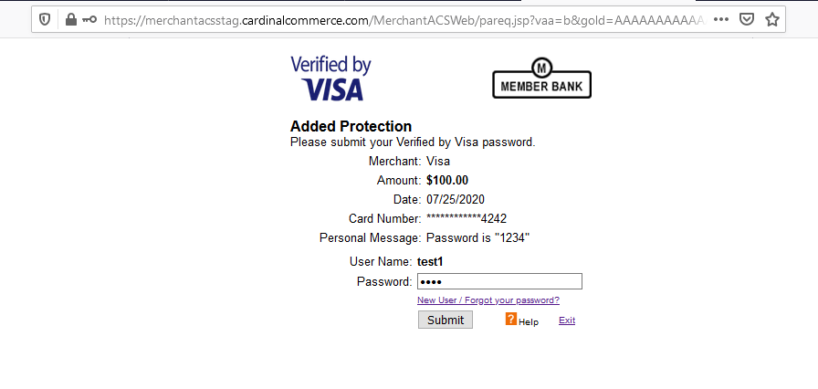

- You can print the receipt or return to the home page
